**ASSIGNMENT 09:**

**DOCKER NETWORK**

Create a container which is accessible from multiple network

**STEP 1:** Launched and EC2 Linux instance, and installed and started docker host on it:

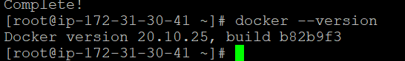

**STEP 2:** ifconfig:

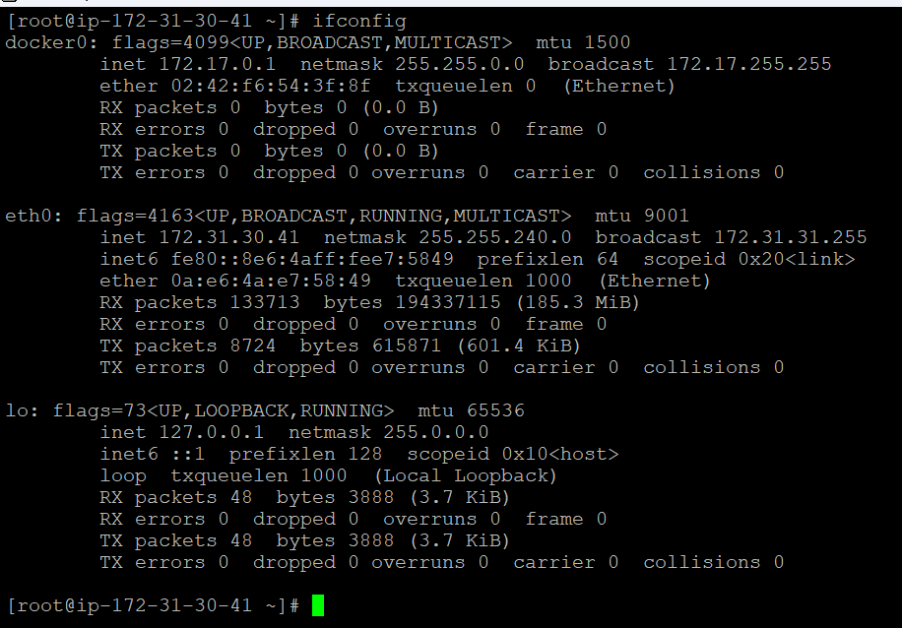

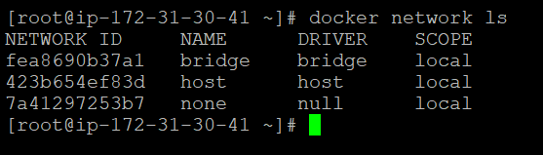

STEP3: Created a new custom bridge network: “test”

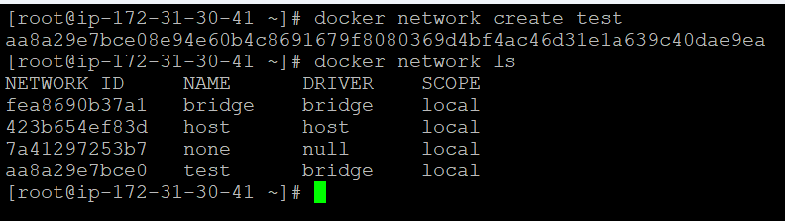

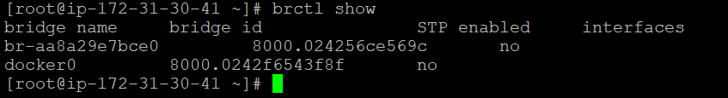

STEP4: Created one container in default bridge and two containers in custom bridge network – test

Default bridge: C1 container [IP- 172.17.0.2]

test network: C2, C3 container [IP- 172.18.0.2 & 172.18.0.2]

docker inspect C1

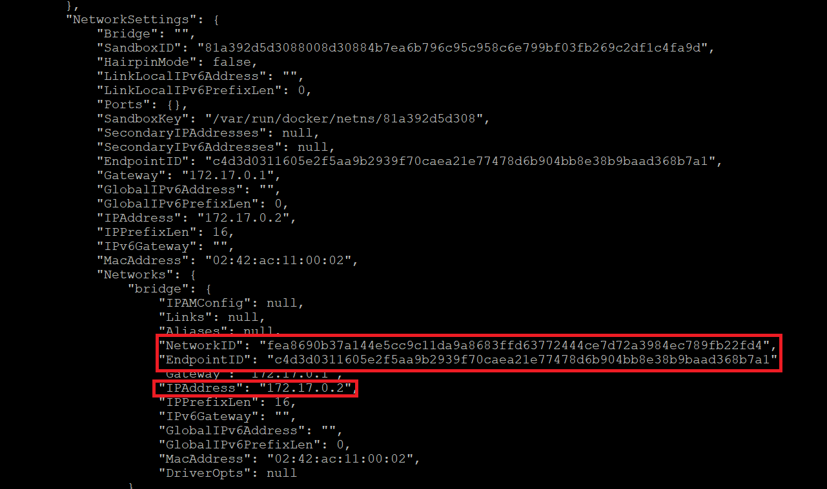

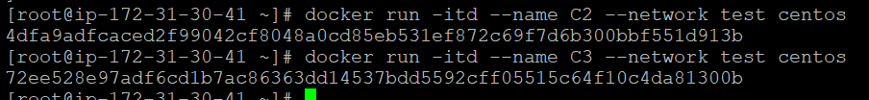All three containers are up and running:

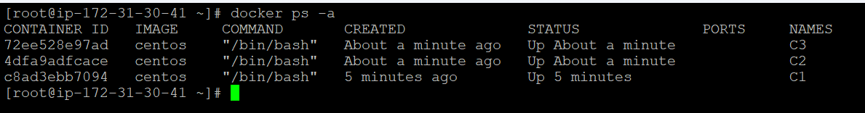

docker inspect c2

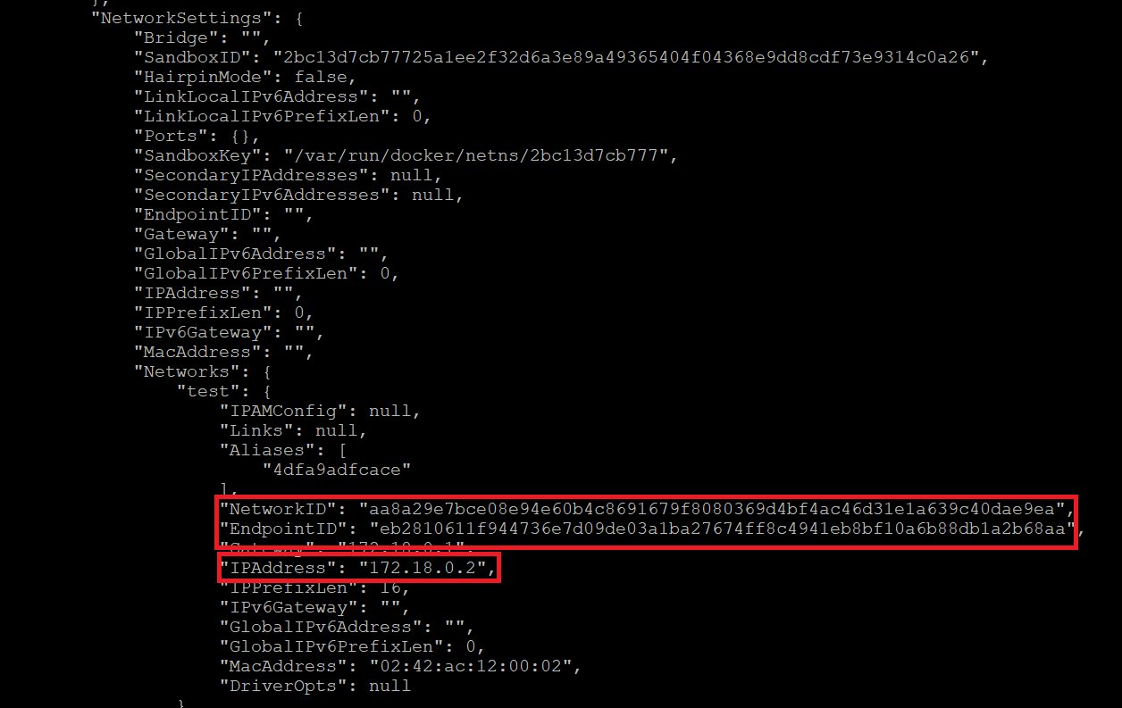

docker inspect C3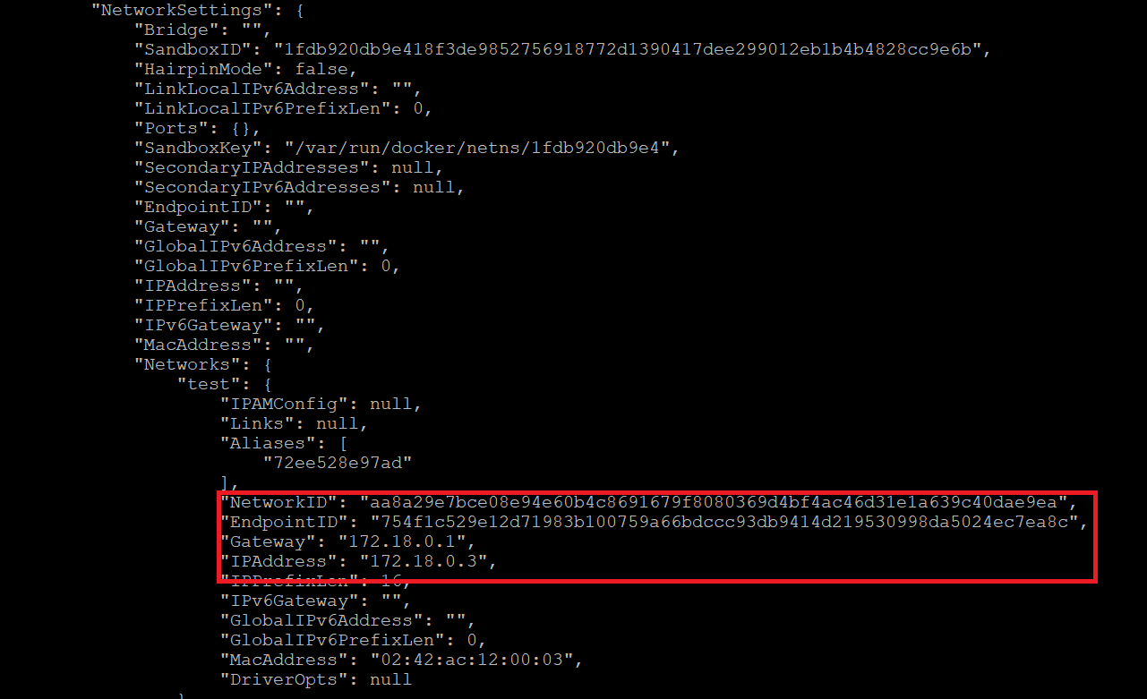

Container C2 & C3 can ping each other but C2 is not able to connect to C1

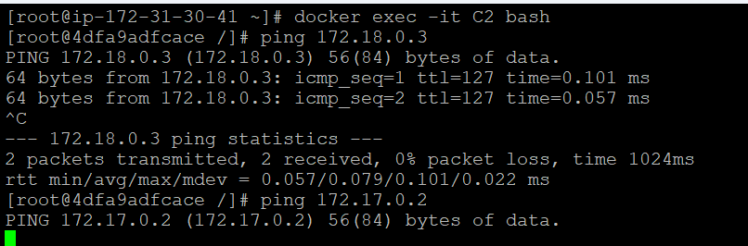

STEP5: Connected a network endpoint to container C2 so it can communicate with C1.

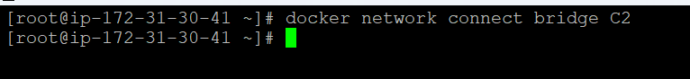

STEP6: C2 has two network endpoint and 2 private ips now

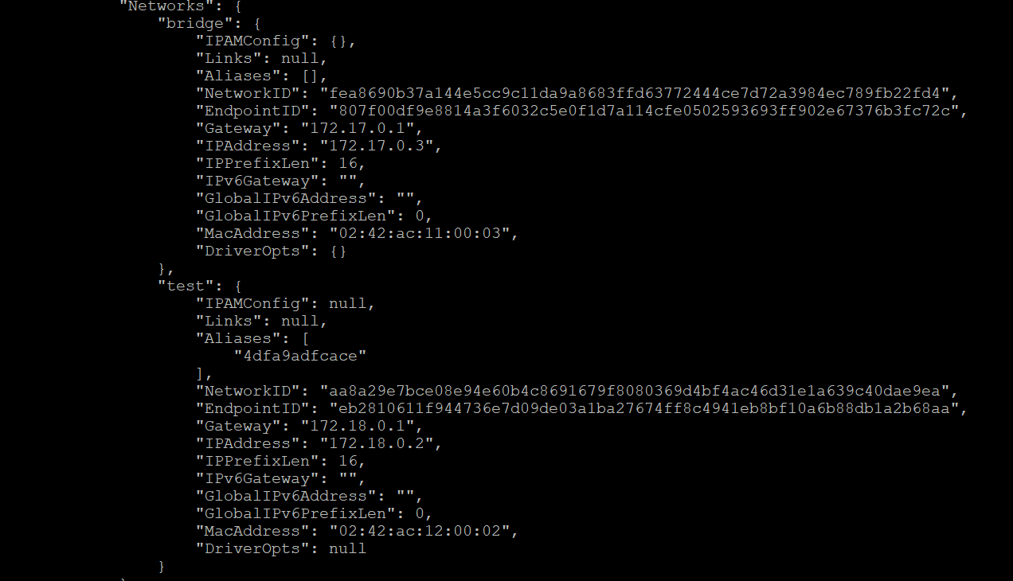

STEP7: Tried pinging C1 from C2 and result is successful.

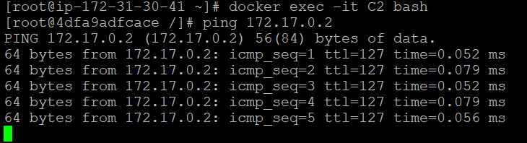

**Graphically explained**

